**EXPERIMENT 1**

**NAME: Vishal Shashikant Salvi UID: 2019230069**

**CLASS: TE COMPS BATCH: C**

**Aim:** To study different types of physical layer wired/wireless connections.

**Theory:**

**Physical layer [1]:**

Physical layer is the lowest layer of the OSI reference model. It is responsible for sending bits from one computer to another. This layer is not concerned with the meaning of the bits and deals with the setup of physical connection to the network and with transmission and reception of signals.  Physical layer is the only layer of OSI network model which actually deals with the physical connectivity of two different stations. This layer defines the hardware equipment, cabling, wiring, frequencies, pulses used to represent binary signals etc.

**Functions of Physical Layer**

Following are the various functions performed by the Physical layer of the OSI model.

1. **Representation of Bits:** Data in this layer consists of stream of bits. The bits must be encoded into signals for transmission. It defines the type of encoding i.e. how 0's and 1's are changed to signal.
2. **Data Rate:**This layer defines the rate of transmission which is the number of bits per second.
3. **Synchronization:**It deals with the synchronization of the transmitter and receiver. The sender and receiver are synchronized at bit level.
4. **Interface:**The physical layer defines the transmission interface between devices and transmission medium.
5. **Line Configuration:**This layer connects devices with the medium: Point to Point configuration and Multipoint configuration.
6. **Topologies:**Devices must be connected using the following topologies: Mesh, Star, Ring and Bus.
7. **Transmission Modes:**Physical Layer defines the direction of transmission between two devices: Simplex, Half Duplex, Full Duplex.
8. Deals with baseband and broadband transmission.

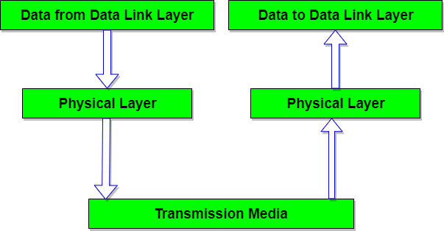

**Modulation [2]:**

Definition: Operation of varying amplitude, frequency or phase of carrier signal accordingly with the instantaneous amplitude of the message signal is called modulation.

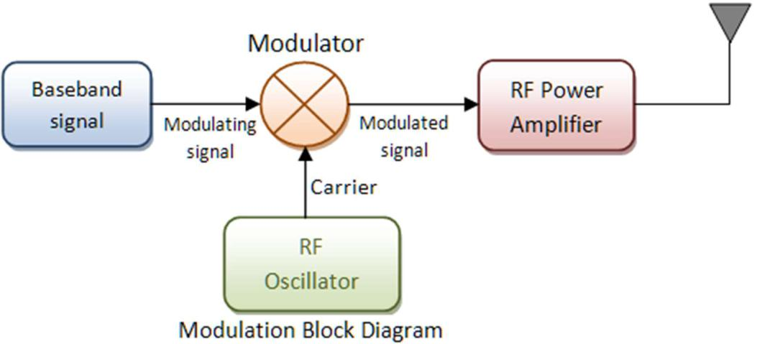

Here baseband signals come from an audio/video or computer. Baseband signals are also called modulating signal as it modulates carrier signal. career signals are high frequency radio waves it generally comes from a radio frequency oscillator. These two signals are combined in modulator. Modulator takes the instantaneous amplitude of baseband signal and varies amplitude/frequency/phase of career signal. Resultant signal is a modulated signal. It goes to an RF-amplifier for signal power boosting and then feed to antenna or a co-axial cable.

There are two types of modulation analog and digital. Analog modulation deals with the voice, video and regular waves of base band signals. Whereas digital modulations are with bit streams or symbols from computing devices as base band signals.

**Analog Modulation:**

Baseband signal is always analog for this modulation. There are three properties of a carrier signal amplitude, frequency and phase thus there are three basic types of analog modulations.

1. Amplitude Modulation (AM)
2. Frequency Modulation (FM)
3. Phase modulation (PM)

**Amplitude Modulation**

Amplitude modulation or AM is the process of varying the instantaneous amplitude of carrier signal accordingly with instantaneous amplitude of message signal.

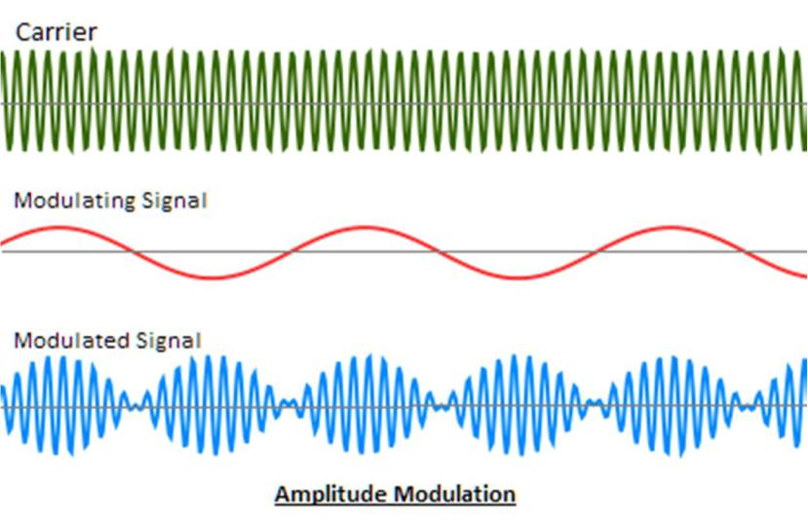

**AM Advantage**

AM is the simplest type of modulation. Hardware design of both transmitter and receiver is very simple and less cost effective.

**AM Disadvantage:**

AM is very susceptible to noise.

**Application:**

1) AM radio broad cast being an example

**Frequency modulation**

FM: -FM or Frequency modulation is the process of varying the in instantaneous frequency of Carrier signal accordingly with instantaneous amplitude of message signal.

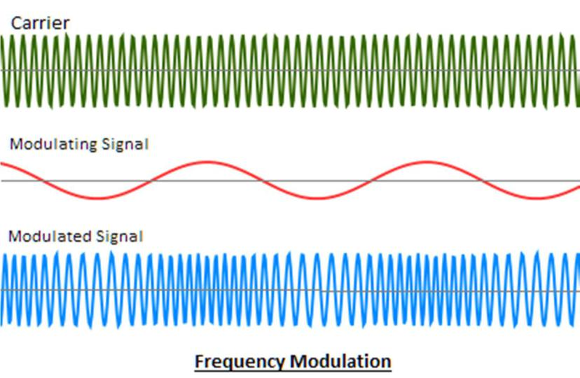

**FM Advantage**

Modulation and demodulation do not catch any channel noise.

**FM Disadvantage:**

Circuit needed for FM modulation and demodulation is bit complicated than AM

**Application:**

1) FM radio broad cast is an example

**Phase modulation (PM)**

PM or Phase modulation is the process of varying the instantaneous phase of Carrier signal

accordingly, with instantaneous amplitude of message signal.

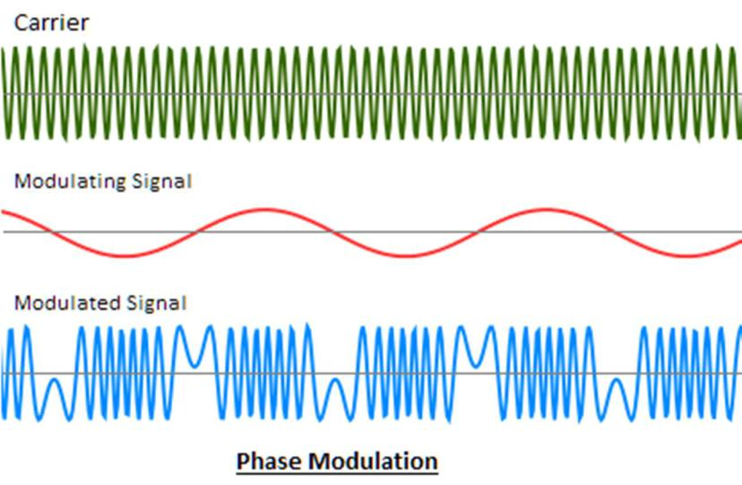

**PM Advantage**

Modulation and demodulation do not catch any channel noise.

**PM Disadvantage:**

Circuit needed for PM modulation and demodulation is bit complicated than AM and FM

**Application:**

1) Satellite communication.

**Digital modulation:**

Digital modulation in somewhat similar to the analog modulation except base band signal is of discrete amplitude level. For binary signal it has only two level, either high or logic 1 or low or logic 0. The modulation scheme is mainly three types.

1. ASK or Amplitude shift Key
2. FSK or Frequency shift key
3. PSK or Phase shift key

**ASK or Amplitude shift Key:**

Amplitude Shift Keying (ASK) is a type of Amplitude Modulation which represents the binary data in the form of variations in the amplitude of a signal.

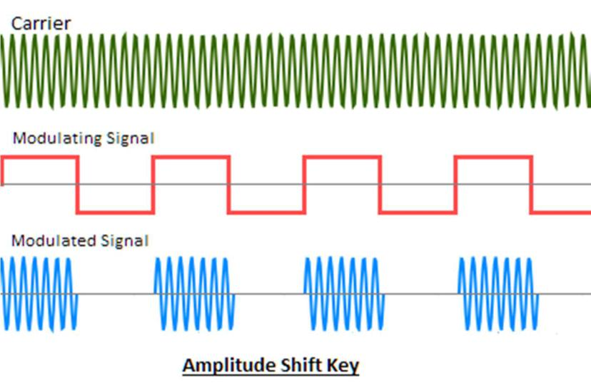

**Application:**

1. Used in our infrared remote controls
2. Used in fiber optical transmitter and receiver.

**FSK or Frequency shift key:**

The frequency of the output signal will be either high or low, depending upon the input data applied.

Frequency Shift Keying (FSK) is the digital modulation technique in which the frequency of the carrier signal varies according to the discrete digital changes. FSK is a scheme of frequency modulation.

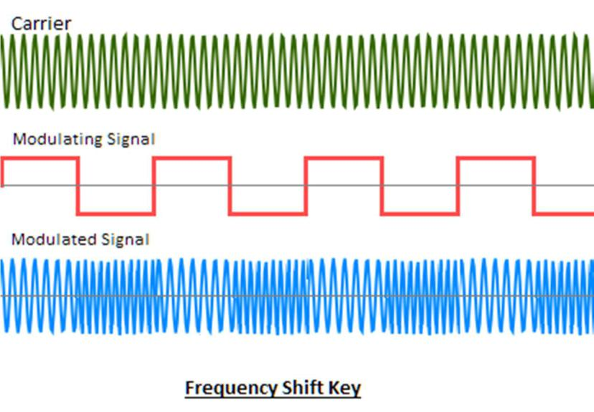

**Application:**

1. Many modems used FSK in telemetry systems

**PSK or Phase shift key:**

The phase of the output signal gets shifted depending upon the input. These are mainly of two types, namely BPSK and QPSK, according to the number of phase shifts. The other one is DPSK which changes the phase according to the previous value.

Phase Shift Keying (PSK) is the digital modulation technique in which the phase of the carrier signal is changed by varying the sine and cosine inputs at a particular time. PSK technique is widely used for wireless LANs, bio-metric, contactless operations, along with RFID and Bluetooth communications.

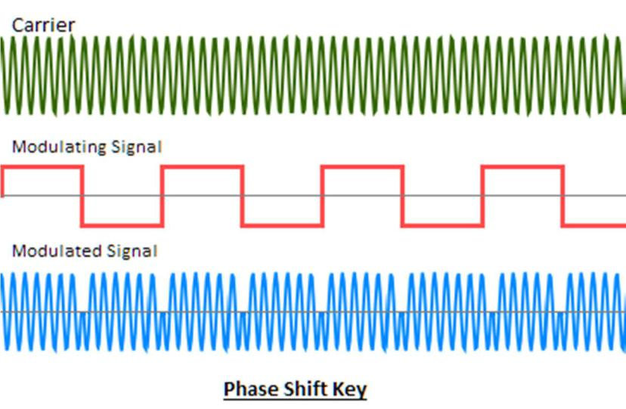

**Application:**

1. Used in our ADSL broadband modem
2. Used in satellite communication
3. Used in our mobile phones

**Transmission media[3]:**

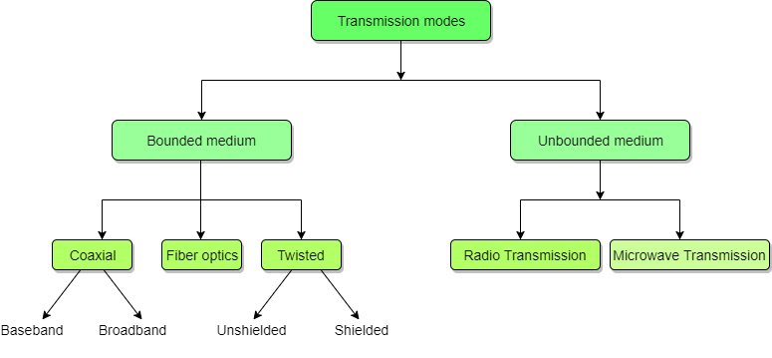

**Bounded/Guided Transmission Media(Wired)**

Guided media, which are those that provide a conduit from one device to another, include **Twisted-Pair Cable**, **Coaxial Cable**, and **Fibre-Optic Cable**.

A signal travelling along any of these media is directed and contained by the physical limits of the medium. Twisted-pair and coaxial cable use metallic (copper) conductors that accept and transport signals in the form of electric current. **Optical fibre** is a cable that accepts and transports signals in the form of light.

**Twisted Pair Cable**

This cable is the most commonly used and is cheaper than others. It is lightweight, cheap, can be installed easily, and they support many different types of network. Some important points :

* Its frequency range is 0 to 3.5 kHz.
* Typical attenuation is 0.2 dB/Km @ 1kHz.
* Typical delay is 50 µs/km.
* Repeater spacing is 2km.

A twisted pair consists of two conductors (normally copper), each with its own plastic insulation, twisted together. One of these wires is used to carry signals to the receiver, and the other is used only as ground reference. The receiver uses the difference between the two. In addition to the signal sent by the sender on one of the wires, interference(noise) and crosstalk may affect both wires and create unwanted signals. If the two wires are parallel, the effect of these unwanted signals is not the same in both wires because they are at different locations relative to the noise or crosstalk sources. This results in a difference at the receiver.

**Twisted Pair is of two types:**

* **Unshielded Twisted Pair (UTP)**
* **Shielded Twisted Pair (STP)**

**Unshielded Twisted Pair Cable**

It is the most common type of telecommunication when compared with Shielded Twisted Pair Cable which consists of two conductors usually copper, each with its own colour plastic insulator. Identification is the reason behind coloured plastic insulation.

UTP cables consist of 2 or 4 pairs of twisted cable. Cable with 2 pair use **RJ-11** connector and 4 pair cable use **RJ-45** connector.

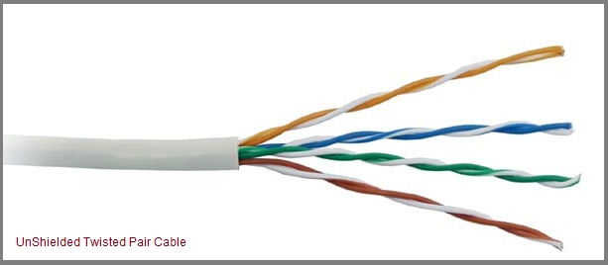

**Advantages**

* Installation is easy
* Flexible
* Cheap
* It has high speed capacity,
* 100-meter limit
* Higher grades of UTP are used in LAN technologies like Ethernet.

It consists of two insulating copper wires (1mm thick). The wires are twisted together in a helical form to reduce electrical interference from similar pair.

**Disadvantages**

* Bandwidth is low when compared with Coaxial Cable
* Provides less protection from interference.

**Four standard types of UTP cabling exist and are still used to varying degrees:**

* **Category 3 cable**—The original type of UTP cable used for Ethernet networks was also the same as that used for business telephone wiring. This is known as Category 3, or voice-grade UTP cable, and it is measured according to a scale that quantifies the cable’s data-transmission capabilities. The cable itself is 24 AWG (American Wire Gauge, a standard for measuring the diameter of a wire) and copper-tinned with solid conductors, with 100–105-ohm characteristic impedance and a minimum of two twists per foot. Category 3 cable is largely obsolete because it is only adequate for networks running at up to 16 Mb/s, so it cannot be used with Fast or gigabit Ethernet.
* **Category 5 cable**—The faster network types require greater performance levels. Fast Ethernet (100BASE-TX) uses the same two-wire pairs as 10BASE-T, but Fast Ethernet needs a greater resistance to signal crosstalk and attenuation. Therefore, the use of Category 5 UTP cabling is essential with 100BASE-TX Fast Ethernet. Although the 100BASE-T4 version of Fast Ethernet can use all four-wire pairs of Category 3 cable, this flavor of Fast Ethernet is not widely supported and has practically vanished from the marketplace. If you try to run Fast Ethernet 100BASE-TX over Category 3 cable, you will have a slow and unreliable network. Category 5 cable is commonly called Cat 5 and is also referred to as Class D cable.
* **Category 5e cable**—Many cable vendors also sell an enhanced form of Category 5 cable called Category 5e (specified by Addendum 5 of the ANSI/TIA/EIA-568-A cabling standard). Category 5e cable can be used in place of Category 5 cable and is especially well suited for use in Fast Ethernet networks that might be upgraded to gigabit Ethernet in the future. Category 5e cabling must pass several tests not required for Category 5 cabling. Even though you can use both Category 5 and Category 5e cabling on a gigabit Ethernet (1000BASE-TX) network, Category 5e cabling provides better transmission rates and a greater margin of safety for reliable data transmission.
* **Category 6 cable**—Category 6 cabling (also called Cat 6 or Class E) can be used in place of Cat 5 or 5e cabling and uses the same 8P8C (RJ45) connectors as Cat 5 and 5e. Cat 6 cable handles a frequency range of 1 MHz–250 MHz, compared to Cat 5 and 5e’s 1 MHz–100 MHz frequency range. Cat 6 is suitable for gigabit Ethernet at standard distances of up to 100 meters (328 ft.), and can even be used for 10 gigabit Ethernet at reduced distances of up to 55 meters (180 ft.).
* **Category 6a cable**—Category 6a cabling (also called Cat 6a or Class EA) can be used in place of Cat 6, 5, or 5e cabling and uses the same 8P8C (RJ45) connectors. Cat 6a cable supports a frequency up to 500 MHz (twice that of Cat 6), and supports 10 gigabit Ethernet connections at the full maximum distance of up to 100 meters (328 ft.).

**Shielded Twisted Pair Cable**

This cable has a metal foil or braided-mesh covering which encases each pair of insulated conductors. Electromagnetic noise penetration is prevented by metal casing. Shielding also eliminates crosstalk (explained in KEY TERMS Chapter).

It has same attenuation as unshielded twisted pair. It is faster the unshielded and coaxial cable. It is more expensive than coaxial and unshielded twisted pair.

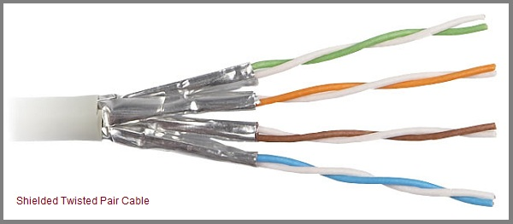

**Advantages**

* Easy to install
* Performance is adequate
* Can be used for Analog or Digital transmission
* Increases the signalling rate
* Higher capacity than unshielded twisted pair
* Eliminates crosstalk

**Disadvantages**

* Difficult to manufacture
* Heavy

**Performance**

One way to measure the performance of twisted-pair cable is to compare attenuation versus frequency and distance. As shown in the below figure, a twisted-pair cable can pass a wide range of frequencies. However, with increasing frequency, the attenuation, measured in decibels per kilometre (dB/km), sharply increases with frequencies above 100kHz. Note that gauge is a measure of the thickness of the wire.

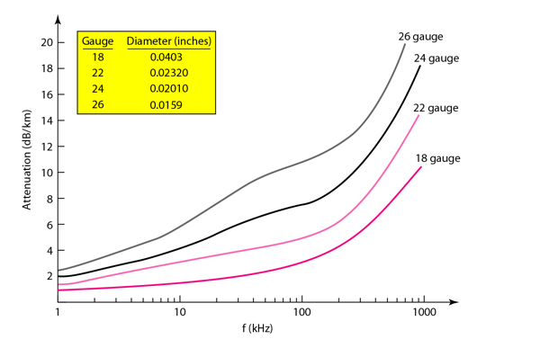

**Applications**

* In telephone lines to provide voice and data channels. The DSL lines that are used by the telephone companies to provide high-data-rate connections also use the high-bandwidth capability of unshielded twisted-pair cables.

Local Area Network, such as 10Base-T and 100Base-T, also use twisted-pair cables

**Ethernet Standards**

Some of the most common Ethernet varieties are summarised below. Mbps indicates a speed in megabits per second and Gbps indicates a speed in Gigabits per second. The term ‘BASE’ means that baseband signalling is used – the signal transmitted uses the full bandwidth of the media.

**10BASE-T**

Friendly Name: Ethernet

IEEE Standard: 802.3

Speed: 10 Mbps

Material: Copper

Maximum length: 100m

**100BASE-TX (also referred to as 100BASE-T)**

Friendly Name: Fast Ethernet

IEEE Standard: 802.3u

Speed: 100Mbps

Material: Copper

Maximum length: 100m

**1000BASE-T**

Friendly Name: Gigabit Ethernet

IEEE Standard: 802.3ab

Speed: 1 Gbps

Material: Copper

Maximum length: 100m

**1000BASE-X**

Friendly Name: Gigabit Ethernet

IEEE Standard: 802.3z

Speed: 1 Gbps

Material: Fibre

Maximum length: depends on fibre properties: 1000BASE-SX approx. 200m to 500m and 1000BASE-LX up to 5km

**10GBASE-T**

Friendly Name: 10 Gig Ethernet

IEEE Standard: 802.3an

Speed: 10Gbps

Material: Copper

Maximum length: 100m

**Coaxial Cable**

Coaxial is called by this name because it contains two conductors that are parallel to each other. Copper is used in this as centre conductor which can be a solid wire or a standard one. It is surrounded by PVC installation, a sheath which is encased in an outer conductor of metal foil, braid or both.

Outer metallic wrapping is used as a shield against noise and as the second conductor which completes the circuit. The outer conductor is also encased in an insulating sheath. The outermost part is the plastic cover which protects the whole cable.

Here the most common coaxial standards.

* 50-Ohm RG-7 or RG-11: used with thick Ethernet.
* 50-Ohm RG-58: used with thin Ethernet
* 75-Ohm RG-59: used with cable television
* 93-Ohm RG-62: used with ARCNET.

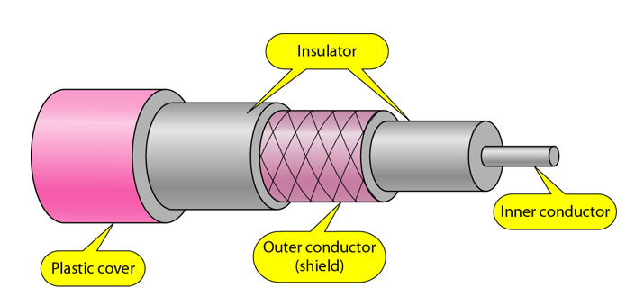

**Coaxial Cable Standards**

Coaxial cables are categorized by their Radio Government(RG) ratings. Each RG number denotes a unique set of physical specifications, including the wire gauge of the inner conductor, the thickness and the type of the inner insulator, the construction of the shield, and the size and type of the outer casing. Each cable defined by an RG rating is adapted for a specialized function, as shown in the table below:

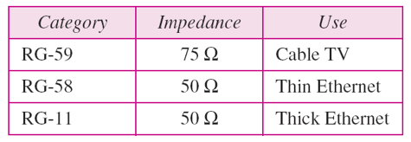

**Coaxial Cable Connectors**

To connect coaxial cable to devices, we need coaxial connectors. The most common type of connector used today is the Bayonet Neill-Concelman (BNC) connector. The below figure shows 3 popular types of these connectors: the BNC Connector, the BNC T connector and the BNC terminator.

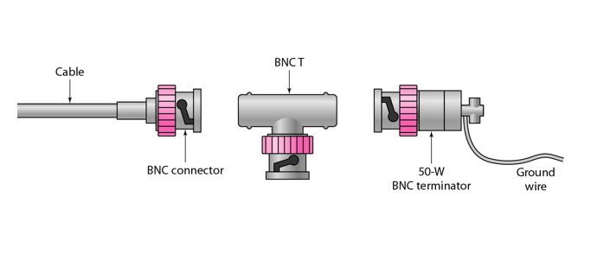

The BNC connector is used to connect the end of the cable to the device, such as a TV set. The BNC T connector is used in Ethernet networks to branch out to a connection to a computer or other device. The BNC terminator is used at the end of the cable to prevent the reflection of the signal.

There are two types of Coaxial cables:

**Baseband**

This is a 50 ohm (Ω) coaxial cable which is used for digital transmission. It is mostly used for LAN's. Baseband transmits a single signal at a time with very high speed. The major drawback is that it needs amplification after every 1000 feet.

**Broadband**

This uses analog transmission on standard cable television cabling. It transmits several simultaneous signals using different frequencies. It covers large area when compared with Baseband Coaxial Cable.

**Advantages**

* Bandwidth is high
* Used in long distance telephone lines.
* Transmits digital signals at a very high rate of 10Mbps.
* Much higher noise immunity
* Data transmission without distortion.
* They can span to longer distance at higher speeds as they have better shielding when compared to twisted pair cable

**Disadvantages**

* Single cable failure can fail the entire network.
* Difficult to install and expensive when compared with twisted pair.
* If the shield is imperfect, it can lead to grounded loop.

**Performance**

We can measure the performance of a coaxial cable in same way as that of Twisted Pair Cables. From the below figure, it can be seen that the attenuation is much higher in coaxial cable than in twisted-pair cable. In other words, although coaxial cable has a much higher bandwidth, the signal weakens rapidly and requires the frequent use of repeaters.

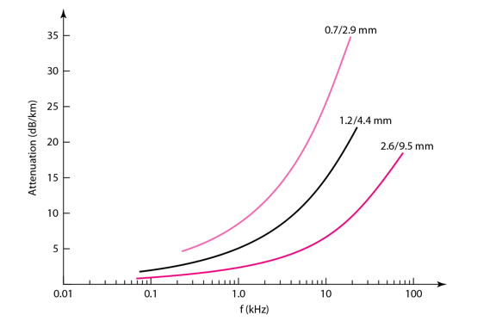

**Applications**

* Coaxial cable was widely used in analog telephone networks, where a single coaxial network could carry 10,000 voice signals.
* Cable TV networks also use coaxial cables. In the traditional cable TV network, the entire network used coaxial cable. Cable TV uses RG-59 coaxial cable.
* In traditional Ethernet LANs. Because of its high bandwidth, and consequence high data rate, coaxial cable was chosen for digital transmission in early Ethernet LANs. The 10Base-2, or Thin Ethernet, uses RG-58 coaxial cable with BNC connectors to transmit data at 10Mbps with a range of 185 m.

**Fiber Optic Cable**

A fibre-optic cable is made of glass or plastic and transmits signals in the form of light.

For better understanding we first need to explore several aspects of the **nature of light**.

Light travels in a straight line as long as it is mobbing through a single uniform substance. If ray of light travelling through one substance suddenly enters another substance (of a different density), the ray changes direction.

The below figure shows how a ray of light changes direction when going from a denser to a less dense substance.

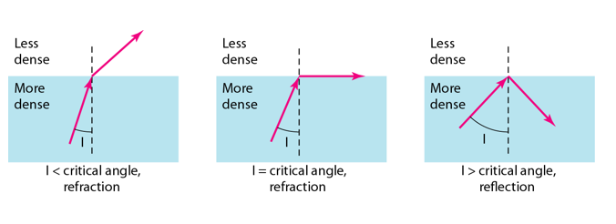

**Bending of a light ray**

As the figure shows:

* If the **angle of incidence I** (the angle the ray makes with the line perpendicular to the interface between the two substances) is **less** than the **critical angle**, the ray **refracts** and moves closer to the surface.
* If the angle of incidence is **greater** than the critical angle, the ray **reflects** (makes a turn) and travels again in the denser substance.
* If the angle of incidence is **equal** to the critical angle, the ray refracts and **moves parallel** to the surface as shown.

**Note:** The critical angle is a property of the substance, and its value differs from one substance to another.

Optical fibres use reflection to guide light through a channel. A glass or plastic core is surrounded by a cladding of less dense glass or plastic. The difference in density of the two materials must be such that a beam of light moving through the core is reflected off the cladding instead of being refracted into it.

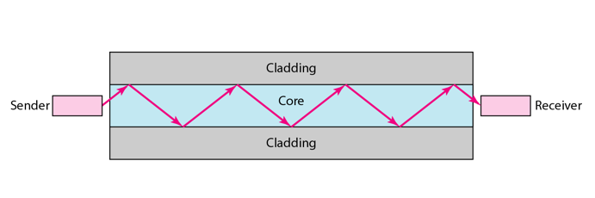 **Internal view of an Optical fibre**

**Fibre-Optic Cable Connectors**

There are three types of connectors for fibre-optic cables, as shown in the figure below.

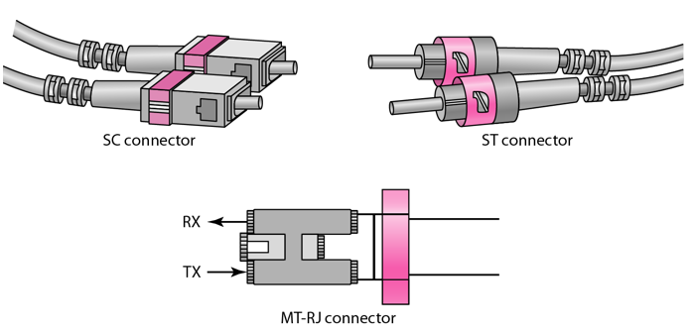

The **Subscriber Channel (SC)** connector is used for cable TV. It uses push/pull locking system. The **Straight-Tip (ST)** connector is used for connecting cable to the networking devices. MT-RJ is a connector that is the same size as RJ45.

**Advantages**

Fibre optic has several advantages over metallic cable:

* Higher bandwidth
* Less signal attenuation
* Immunity to electromagnetic interference
* Resistance to corrosive materials
* Light weight
* Greater immunity to tapping

**Disadvantages**

There are some disadvantages in the use of optical fibre:

* Installation and maintenance
* Unidirectional light propagation
* High Cost

**Performance**

Attenuation is flatter than in the case of twisted-pair cable and coaxial cable. The performance is such that we need fewer (actually one tenth as many) repeaters when we use the fibre-optic cable.

**Applications**

* Often found in backbone networks because its wide bandwidth is cost-effective.
* Some cable TV companies use a combination of optical fibre and coaxial cable thus creating a hybrid network.
* Local-area Networks such as 100Base-FX network and 1000Base-X also use fibre-optic cable.

#### **Cable Distance Limitations**

The people who design computer systems love to find ways to circumvent limitations. Manufacturers of Ethernet products have made possible the building of networks in star, branch, and tree designs that overcome the basic limitations already mentioned. (For more information, see the “Wired Network Topologies” section later in this chapter.) Strictly speaking, you can have thousands of computers on a complex Ethernet network.

LANs are local because the network adapters and other hardware components typically can’t send LAN messages more than a few hundred feet. The table below lists the distance limitations of various types of LAN cable.

|  |  |  |  |
| --- | --- | --- | --- |
| Network Distance Limitations | | | |
| Network Adapter | Cable Type | Maximum | Minimum |
| Ethernet | 10BASE-2 | 185 m (607 feet) | 0.5 m (1.6 feet) |
| 10BASE-5 (drop) | 50 m (164 feet) | 2.5 m (8.2 feet) |
| 10BASE-5 (backbone) | 500 m (1640 feet) | 2.5 m (8.2 feet) |
| 10BASE-T | 100 m (328 feet) | 2.5 m (8.2 feet) |
| 100BASE-TX | 100 m (328 feet) | 2.5 m (8.2 feet) |
| 1000BASE-TX | 100 m (328 feet) | 2.5 m (8.2 feet) |
| 10GBASE-T | 100 m (328 feet) | 2.5 m (8.2 feet) |
| Token Ring | STP | 100 m (328 feet) | 2.5 m (8.2 feet) |
| UTP | 45 m (147 feet) | 2.5 m (8.2 feet) |
| ARCnet | Passive hub drop | 30 m (98 feet) | Varies by cable type |
| Active hub | 600 m (1968 feet) | Varies by cable typ |

**Unbounded/Unguided Transmission Media(Wireless)**

Unguided medium transport electromagnetic waves without using a physical conductor. This type of communication is often referred to as wireless communication. Signals are normally broadcast through free space and thus are available to anyone who has a device capable of receiving them.

The below figure shows the part of the electromagnetic spectrum, ranging from 3 kHz to 900 THz, used for wireless communication.

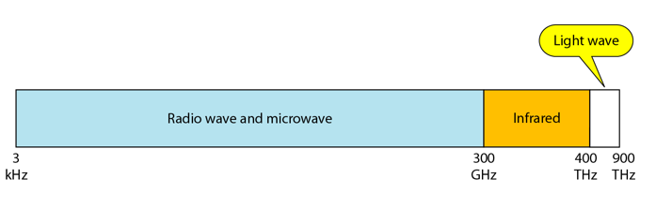

Unguided signals can travel from the source to the destination in several ways: **Ground propagation**, **Sky propagation** and **Line-of-sight propagation** as shown in below figure.

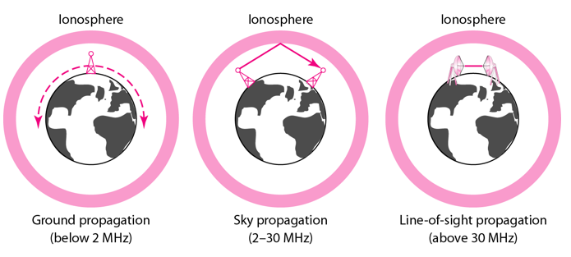

**Propagation Modes**

* **Ground Propagation:** In this, radio waves travel through the lowest portion of the atmosphere, hugging the Earth. These low-frequency signals emanate in all directions from the transmitting antenna and follow the curvature of the planet.
* **Sky Propagation:** In this, higher-frequency radio waves radiate upward into the ionosphere where they are reflected back to Earth. This type of transmission allows for greater distances with lower output power.
* **Line-of-sight Propagation:** in this type, very high-frequency signals are transmitted in straight lines directly from antenna to antenna.

We can divide wireless transmission into three broad groups:

1. Radio waves
2. Micro waves
3. Infrared waves

**Radio Waves**

Electromagnetic waves ranging in frequencies between 3 KHz and 1 GHz are normally called radio waves.

Radio waves are omnidirectional. When an antenna transmits radio waves, they are propagated in all directions. This means that the sending and receiving antennas do not have to be aligned. A sending antenna send waves that can be received by any receiving antenna. The omnidirectional property has disadvantage, too. The radio waves transmitted by one antenna are susceptible to interference by another antenna that may send signal suing the same frequency or band.

Radio waves, particularly with those of low and medium frequencies, can penetrate walls. This characteristic can be both an advantage and a disadvantage. It is an advantage because, an AM radio can receive signals inside a building. It is a disadvantage because we cannot isolate a communication to just inside or outside a building.

**Omnidirectional Antenna**

Radio waves use omnidirectional antennas that send out signals in all directions.

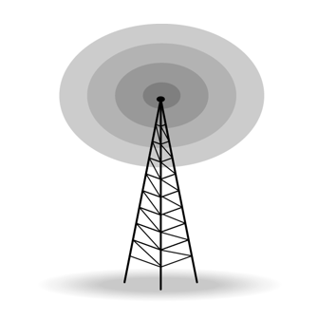

**Applications**

* The omnidirectional characteristics of radio waves make them useful for multicasting in which there is one sender but many receivers.
* AM and FM radio, television, maritime radio, cordless phones, and paging are examples of multicasting.

**Micro Waves**

Electromagnetic waves having frequencies between 1 and 300 GHz are called micro waves. Micro waves are unidirectional. When an antenna transmits microwaves, they can be narrowly focused. This means that the sending and receiving antennas need to be aligned. The unidirectional property has an obvious advantage. A pair of antennas can be aligned without interfering with another pair of aligned antennas.

The following describes some characteristics of microwaves propagation:

* Microwave propagation is line-of-sight. Since the towers with the mounted antennas need to be in direct sight of each other, towers that are far apart need to be very tall.
* Very high-frequency microwaves cannot penetrate walls. This characteristic can be a disadvantage if receivers are inside the buildings.
* The microwave band is relatively wide, almost 299 GHz. Therefore, wider sub-bands can be assigned and a high date rate is possible.
* Use of certain portions of the band requires permission from authorities.

**Unidirectional Antenna**

Microwaves need unidirectional antennas that send out signals in one direction. Two types of antennas are used for microwave communications: **Parabolic Dish** and **Horn**.

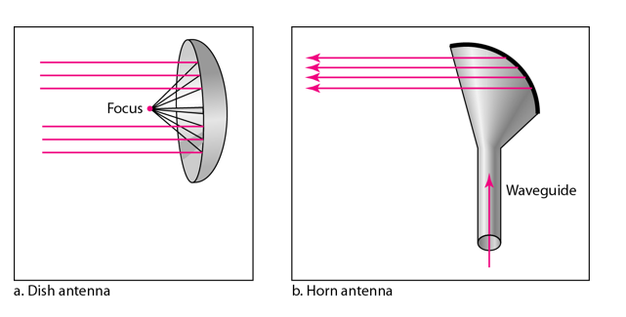

A parabolic antenna works as a funnel, catching a wide range of waves and directing them to a common point. In this way, more of the signal is recovered than would be possible with a single-point receiver.

A horn antenna looks like a gigantic scoop. Outgoing transmissions are broadcast up a stem and deflected outward in a series of narrow parallel beams by the curved head. Received transmissions are collected by the scooped shape of the horn, in a manner similar to the parabolic dish, and are deflected down into the stem.

**Applications**

Microwaves, due to their unidirectional properties, are very useful when unicast(one-to-one) communication is needed between the sender and the receiver. They are used in cellular phones, satellite networks and wireless LANs.

There are 2 types of Microwave Transmission:

1. Terrestrial Microwave
2. Satellite Microwave

**Advantages of Microwave Transmission**

* Used for long distance telephone communication
* Carries 1000's of voice channels at the same time

**Disadvantages of Microwave Transmission**

* It is Very costly

**Terrestrial Microwave**

For increasing the distance served by terrestrial microwave, repeaters can be installed with each antenna. The signal received by an antenna can be converted into transmittable form and relayed to next antenna as shown in below figure. It is an example of telephone systems all over the world

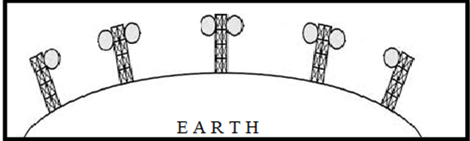

There are two types of antennas used for terrestrial microwave communication:

**1. Parabolic Dish Antenna**

In this every line parallel to the line of symmetry reflects off the curve at angles in a way that they intersect at a common point called focus. This antenna is based on geometry of parabola.

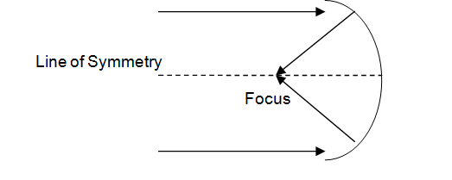

**2. Horn Antenna**

It is a like gigantic scoop. The outgoing transmissions are broadcast up a stem and deflected outward in a series of narrow parallel beams by curved head.

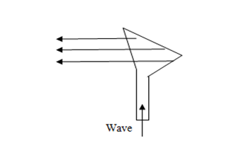

**Satellite Microwave**

This is a microwave relay station which is placed in outer space. The satellites are launched either by rockets or space shuttles carry them.

These are positioned 36000KM above the equator with an orbit speed that exactly matches the rotation speed of the earth. As the satellite is positioned in a geo-synchronous orbit, it is stationery relative to earth and always stays over the same point on the ground. This is usually done to allow ground stations to aim antenna at a fixed point in the sky.

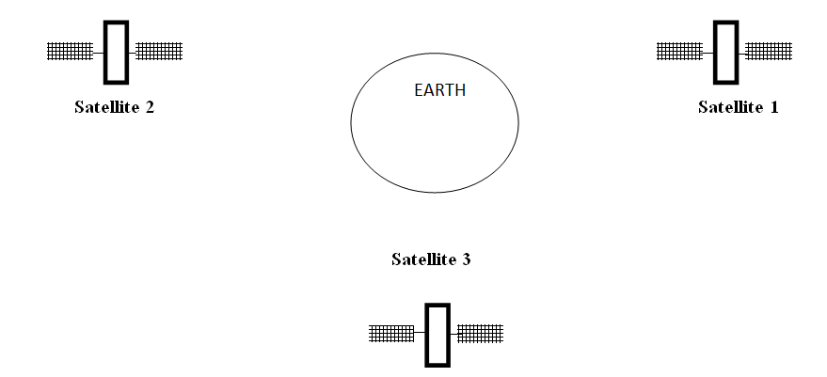

**Features of Satellite Microwave:**

* Bandwidth capacity depends on the frequency used.
* Satellite microwave deployment for orbiting satellite is difficult.

**Advantages of Satellite Microwave:**

* Transmitting station can receive back its own transmission and check whether the satellite has transmitted information correctly.
* A single microwave relay station which is visible from any point.

**Disadvantages of Satellite Microwave:**

* Satellite manufacturing cost is very high
* Cost of launching satellite is very expensive
* Transmission highly depends on whether conditions, it can go down in bad weather

**Infrared Waves**

Infrared waves, with frequencies from 300 GHz to 400 THz, can be used for short-range communication. Infrared waves, having high frequencies, cannot penetrate walls. This advantageous characteristic prevents interference between one system and another, a short-range communication system in on room cannot be affected by another system in the next room.

When we use infrared remote control, we do not interfere with the use of the remote by our neighbours. However, this same characteristic makes infrared signals useless for long-range communication. In addition, we cannot use infrared waves outside a building because the sun's rays contain infrared waves that can interfere with the communication.

**Applications**

* The infrared band, almost 400 THz, has an excellent potential for data transmission. Such a wide bandwidth can be used to transmit digital data with a very high data rate.
* The Infrared Data Association (IrDA), an association for sponsoring the use of infrared waves, has established standards for using these signals for communication between devices such as keyboards, mouse, PCs and printers.
* Infrared signals can be used for short-range communication in a closed area using line-of-sight propagation.

3.2.2 Network connectors: RJ45, BNC, Optical transceiver modules, optical devices, connectors: SC, ST

**Bluetooth[4]:**

Bluetooth is a wireless technology standard used for exchanging data between fixed and mobile devices over short distances using short-wavelength UHF radio waves in the industrial, scientific and medical radio bands, from 2.402 GHz to 2.480 GHz, and building personal area networks (PANs). It was originally conceived as a wireless alternative to RS-232 data cables.

Bluetooth is a packet-based protocol with a master/slave architecture. One master may communicate with up to seven slaves in a piconet. All devices within a given piconet use the clock provided by the master as the base for packet exchange. Packets may be 1, 3 or 5 slots long, but in all cases the master's transmission begins in even slots and the slave's in odd slots.

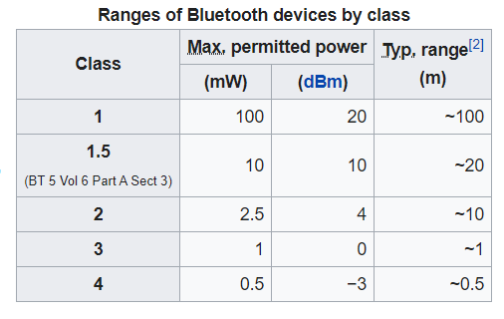

**Network structure:**

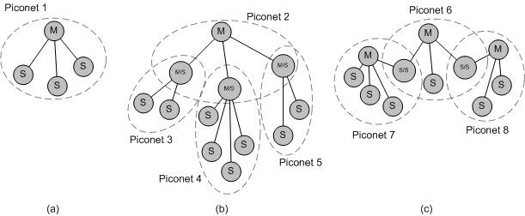

**Communication:**

A master Bluetooth device can communicate with a maximum of seven devices in a piconet (an ad-hoc computer network using Bluetooth technology), though not all devices reach this maximum. The devices can switch roles, by agreement, and the slave can become the master (for example, a headset initiating a connection to a phone necessarily begins as master as an initiator of the connection but may subsequently operate as the slave).

The Bluetooth Core Specification provides for the connection of two or more piconets to form a scatternet, in which certain devices simultaneously play the master role in one piconet and the slave role in another.

**Wi-Fi:**

Wi-Fi is a family of wireless network protocols, based on the IEEE 802.11 family of standards, which are commonly used for local area networking of devices and Internet access.

Wi-Fi uses multiple parts of the IEEE 802 protocol family and is designed to interwork seamlessly with its wired sibling Ethernet. Compatible devices can network through wireless access points to each other as well as to wired devices and the Internet. The different versions of Wi-Fi are specified by various IEEE 802.11 protocol standards, with the different radio technologies determining radio bands, and the maximum ranges, and speeds that may be achieved. Wi-Fi most commonly uses the 2.4 gigahertz (120 mm) UHF and 5 gigahertz (60 mm) SHF ISM radio bands; these bands are subdivided into multiple channels. Channels can be shared between networks but only one transmitter can locally transmit on a channel at any moment in time.

**Versions:**

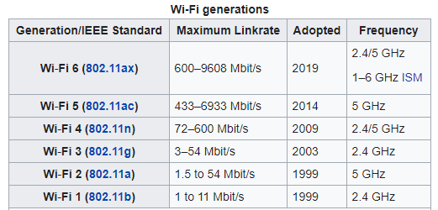

**WiMAX** **[5]:**

WiMAX (Worldwide Interoperability for Microwave Access) is a family of wireless broadband communication standards based on the IEEE 802.16 set of standards, which provide multiple physical layer and Media Access Control options.

WiMAX was initially designed to provide 30 to 40 megabit-per-second data rates, with the 2011 update providing up to 1 Gbit/s for fixed stations.

The original version of the standard on which WiMAX is based (IEEE 802.16) specified a physical layer operating in the 10 to 66 GHz range.

802.16a, updated in 2004 to 802.16-2004, added specifications for the 2 to 11 GHz range. 802.16-2004 was updated by 802.16e-2005 in 2005 and uses scalable orthogonal frequency-division multiple access (SOFDMA), as opposed to the fixed orthogonal frequency-division multiplexing (OFDM) version with 256 sub-carriers (of which 200 are used) in 802.16d. More advanced versions, including 802.16e, also bring multiple antenna support through MIMO. (See WiMAX MIMO) This brings potential benefits in terms of coverage, self installation, power consumption, frequency reuse and bandwidth efficiency. WiMax is the most energy-efficient pre-4G technique among LTE and HSPA+.

**WiMax Speed and Range**

WiMAX is expected to offer initially up to about 40 Mbps capacity per wireless channel for both fixed and portable applications, depending on the particular technical configuration chosen, enough to support hundreds of businesses with T-1 speed connectivity and thousands of residences with DSL speed connectivity. WiMAX can support voice and video as well as Internet data.

WiMAX developed to provide wireless broadband access to buildings, either in competition to existing wired networks or alone in currently unserved rural or thinly populated areas. It can also be used to connect WLAN hotspots to the Internet. WiMAX is also intended to provide broadband connectivity to mobile devices. It would not be as fast as in these fixed applications, but expectations are for about 15 Mbps capacity in a 3 km cell coverage area.

With WiMAX, users could really cut free from today's Internet access arrangements and be able to go online at broadband speeds, almost wherever they like from within a Metro Zone.

WiMAX could potentially be deployed in a variety of spectrum bands: 2.3GHz, 2.5GHz, 3.5GHz, and 5.8GHz

**ZigBee[6]:**

The technology defined by the Zigbee specification is intended to be simpler and less expensive than other wireless personal area networks (WPANs), such as Bluetooth or more general wireless networking such as Wi-Fi. Applications include wireless light switches, home energy monitors, traffic management systems, and other consumer and industrial equipment that require short-range low-rate wireless data transfer.

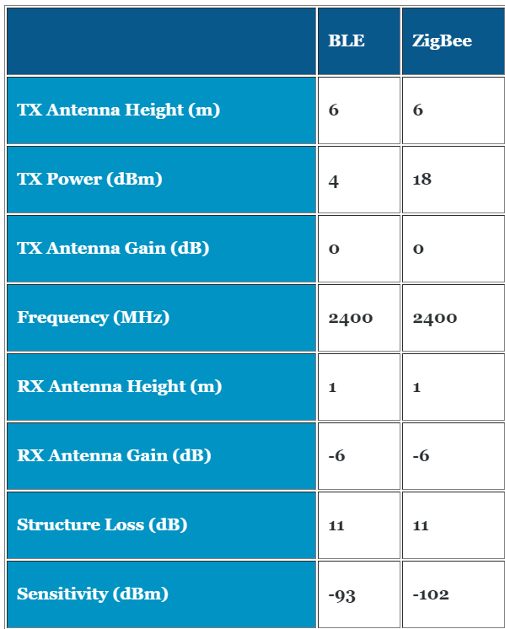

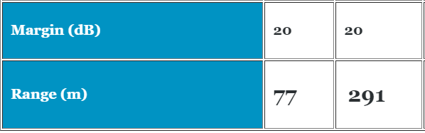

**Wireless MAN**

This family of standards covers Fixed and Mobile Broadband Wireless Access methods used to create Wireless Metropolitan Area Networks (WMANs.) Connects Base Stations to the Internet using OFDM in unlicensed (900 MHz, 2.4, 5.8 GHz) or licensed (700 MHz, 2.5 – 3.6GHz) frequency bands. It implements 802.16 standards.

**Other Transmission Media:**

**LIFI[7]:**

WiFi runs our life. In fact, according to a survey carried out by Direct Line by Opinium Research online, it is the number one thing that their respondents couldn’t live without. But no matter where you are in the world, you’ve probably experienced internet connectivity problems at one point or another.

Enter LiFi, a type of wireless connection that can be up to 100 times faster than WiFi.

Imagine a world where you can connect to high-speed internet by just flicking on your light switch. LiFi is a wireless optical networking technology that uses LEDs for data transmission. In simpler terms, LiFi is considered to be as a light-based WiFi which uses light instead of radio waves to transmit information. Using light to transmit data allows LiFi to deliver a couple of advantages such as working in areas susceptible to electromagnetic interference like hospitals and aircraft cabins and working across higher bandwidth while offering higher transmission speeds.

The LiFi technology is currently being developed by numerous organizations around the world.

## How does LiFi work?

LiFi is a Visible Light Communications system transmitting wireless internet communications at very high speeds. The technology makes a LED light bulb emit pulses of light that are undetectable to the human eye and within those emitted pulses, data can travel to and from receivers. Then, the receivers collect information and interpret the transmitted data. This is conceptually similar to decoding Morse code but in a much faster rate – millions times a second. LiFi transmission speeds can go over 100 Gbps, 14 times faster than WiGig, also known as the world’s fastest WiFi.

Whereas WiFi technology effects data transfer on radio waves, LiFi takes the next revolutionary step in wireless evolution and embeds and transfers data in visible light beams, thereby allowing LiFi to take full advantage of the vastly greater light spectrum bandwidth capacity that is provided by the light spectrum.

p

#### **How it works exactly**

Data is captured in modulated light frequencies of a solid-sate LED light source and is then transmitted and received by LiFi-enabled devices. A photosensitive detector demodulates the light frequency signal and converts it back into an electronic data stream and – in so doing – allows for faster-than-ever, more secure, bi-directional wireless communication.

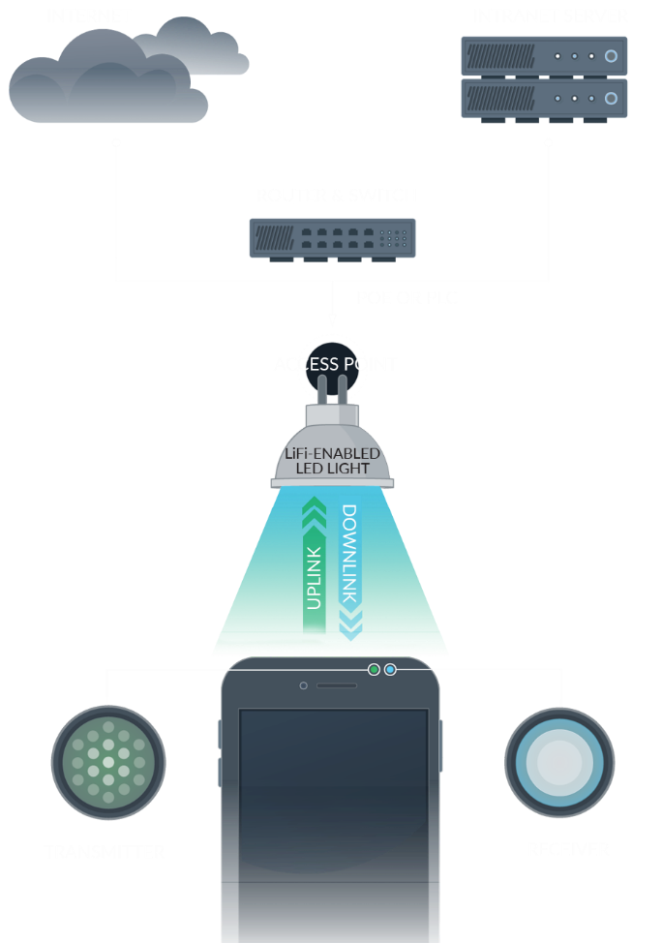

**3G 4G 5G[8]:**

|  |  |  |  |
| --- | --- | --- | --- |
| Network Type | | Download Speed | Upload Speed |
| 3G | 7.2Mbps | | 2Mbps |
| 3G HSPA+ | 42Mbps | | 22Mbps |
| 4G LTE | 150Mbps | | 50Mbps |
| 4G LTE-Advanced | 300Mbps | | 150Mbps |
| 5G | 10Gbps+ | | 1Gbp |

|  |  |  |
| --- | --- | --- |
| Network Type | Download Speed (Mbps) | Upload Speed (Mbps) |
| 3G | 3 | 0.4 |
| 3G HSPA+ | 6 | 3 |
| 4G LTE | 20 | 10 |
| 4G LTE-Advanced | 42 | 25 |
| 5G | 200 | 100 |

**3G**is the slowest speed you’ll usually be browsing on. It has a typical real-world download speed of 3Mbps and a theoretical maximum download speed of 7.2Mbps. If you want to stream a video via 3G from YouTube for example you could be waiting up to ten seconds for it to load. While downloading a 500MB file can take around 22 minutes, with larger apps, movies and albums taking far longer still.

Basic 3G‘s upload speed is a lot slower than its download speed, with typical speeds of 0.4Mbps and a theoretical limit of 2Mbps. In practice 3G is generally fine for web browsing and social networks, you’ll just have to wait a few seconds for pages to load. It would take 3.5 minutes to upload a 10MB file or image.

**3G HSPA+** is an enhanced version of 3G, , and it’s the minimum speed you’ll usually get on a UK network. It offers typical download speeds of 6Mbps and a theoretical maximum of 42Mbps. You can expect streaming videos to load in around 5 seconds and medium sized apps to download in one minute plus, whilst the same 500MB file mentioned above would take 11 minutes to download.

3G HSPA+ provides upload speeds of around 3Mbps and the theoretical maximum is around 22Mbps. At average speeds a 10MB file or image would take around 27 seconds to upload.

**4G (4G LTE)** offers typical download speeds of around 20Mbps and theoretical ones of 150Mbps. So for example, you could download a medium sized app in under 15 seconds or load a YouTube video in under 2 seconds. The same 500MB file should be downloadable in under 4 minutes.

4G boosts upload speeds to 8Mbps on average and 50Mbps at the very top end. The same 10MB file or image would take just 1.25 seconds to download.

**4G LTE-Advanced** is a faster version of 4G with typical real-world download speeds of 42Mbps and theoretical limits of 300Mbps.

EE has launched this service in London, Birmingham, Liverpool and Manchester, with partial coverage in a number of other UK cities, under the name 4G+, while Vodafone has rolled it out to London, Birmingham, Manchester, Liverpool, Cardiff, Nottingham, Bristol and numerous other locations.

Three has also now launched a 4G+ service, with coverage in major cities such as London, Birmingham, Cardiff, Edinburgh and Glasgow.

In fact, coverage on all these networks is probably far wider than the lists above, but they haven’t revealed up to date lists of the places with LTE-Advanced.

With LTE-Advanced (also known as 4G+, LTE-A or 4.5G) videos will load without a discernible pause and a 500MB file will download in under 2 minutes. In fact, it’s even faster than many home broadband connections.

4G LTE-Advanced offers upload speeds of 30Mbps and can theoretically reach 150Mbps. At 30Mbps the same 10MB file or image would take just 2 seconds to upload.

**5G** is the fastest mobile network technology available and at the time of writing real-world download speeds are averaging around 130-250Mbps, but networks claim peak speeds of 1Gbps or more are already possible, and in future 5G could become far faster still, once the infrastructure and technologies improve.

Using those average speeds, a 500MB file would be downloaded in under 30 seconds. There’s less data on upload speeds, but it’s likely to average at most around half the download speed, meaning around 65-120Mbps. At those speeds the uploading of a 10MB file would take 1 second or less.

**USB[9]:**

A Universal Serial Bus (USB) is a common interface that enables communication between devices and a host controller such as a personal computer (PC) or smartphone. It connects peripheral devices such as digital cameras, mice, keyboards, printers, scanners, media devices, external hard drives and flash drives. Because of its wide variety of uses, including support for electrical power, the USB has replaced a wide range of interfaces like the parallel and serial port.

A USB is intended to enhance plug-and-play and allow hot swapping. Plug-and-play enables the operating system (OS) to spontaneously configure and discover a new peripheral device without having to restart the computer. As well, hot swapping allows removal and replacement of a new peripheral without having to reboot.

The Universal Serial Bus (USB) specification stipulates five data transfer rates:

* USB 1.0/Low-Speed: 1.5 Megabits per second (Mbps)

USB 1.0

* USB 1.1/Full-Speed: 12 Mbps

USB 1.1

* USB 2.0/Hi-Speed: 480 Mbps



* USB 3.0/SuperSpeed: 5 Gbps



* USB 3.1/SuperSpeed: 10 Gbps



**References:**

1]<https://www.studytonight.com/computer-networks/osi-model-physical-layer>

2]Modulation:

<https://www.tutorialspoint.com/principles_of_communication/principles_of_communication_digital_modulation_techniques.htm>

3]Transmission media

<https://turbofuture.com/misc/Data-Communication>

<http://citengg.blogspot.com/p/behrouz-forouzancomputer-networks4th.html>

4]Bluetooth:

<https://en.wikipedia.org/wiki/Bluetooth>

<https://www.electronics-notes.com/articles/connectivity/bluetooth/what-is-bluetooth-technology-basics-summary.php>

5]WiMax:

<https://en.wikipedia.org/wiki/WiMAX>

<https://www.tutorialspoint.com/wimax/index.htm>

6]Zigbee:

<https://www.link-labs.com/blog/zigbee-vs-bluetooth>

7]Lifi:

<https://lifi.co/what-is-lifi/>

8]3G 4G 5G:

<https://www.4g.co.uk/how-fast-is-4g/>

9]USB:

<https://www.sony.com/electronics/support/articles/00024571>

**Conclusion:**

Thus, I studied different types of Physical Layer Wired/ Wireless connections.